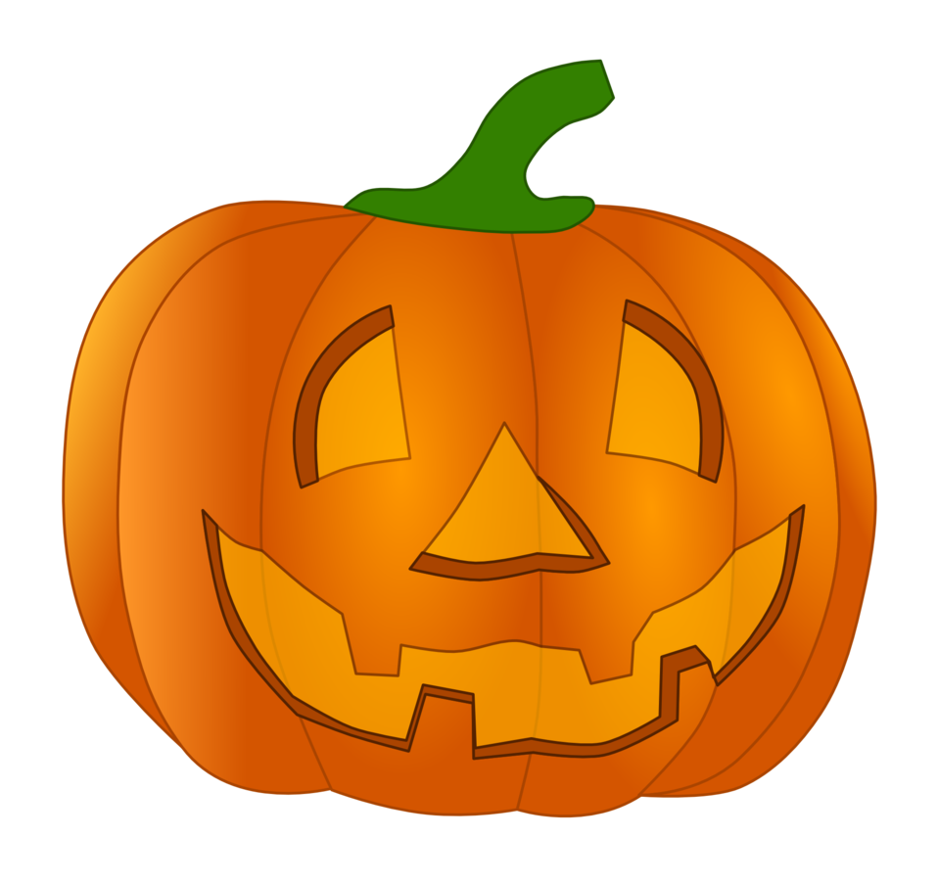

**October News**

Happy October! It is going to be a busy, but fun month! Read below for important info. As always, if you have any questions or concerns, feel free to reach me on the Remind App or talk to me after class.

* Book orders are due on the 10th. You may order online using our class code: Z4QJM or you may bring in exact cash in an envelope with your order form.
* Goal for October: Table manners. Using please and thank you, not getting up from the table frequently, not being silly at the table and eating nicely.
* If you have extra pumpkins, sunflowers, or gourds growing in your garden, we would love to have them! I am planning on doing a surprise pumpkin patch for the kids out in our play area since we do not go on field trips. My goal is to get enough pumpkins so each child can take one home with them. This will be a complete surprise, so please do not tell your child. I want it to be magical for them!
* This month’s themes are Farm, 5 Senses, Pumpkins, and Halloween. Please check the Boys and Girls Club website for exact dates.
* October snack ideas: Small oranges, orange Jell-O, carrots, black olives, orange crackers (Cheez-It crackers or Goldfish), apple sauce, popcorn, sandwiches in the shape of pumpkins, and orange peppers. We also love Halloween themed snacks!

**HALLOWEEN PARTY**

**Wednesday the 30th (4's Class)** OR **Thursday the 31st (3's Class)**

*Last 45 minutes of class!*

We dress up in our costumes and “trick or treat” each other the last 45 minutes of class. Each child needs to wear their costume and bring 23 little treats. Treats can be anything - stickers, pencils, candy, squishies, anything easy and/or fun for you.

I like to take photos so I want kids to wear their costumes.